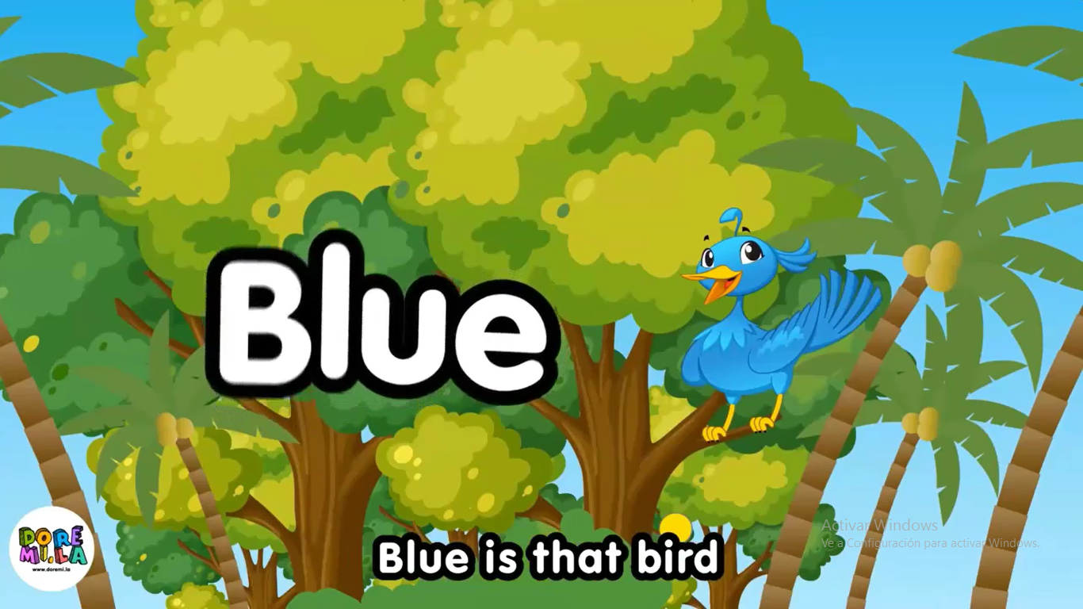

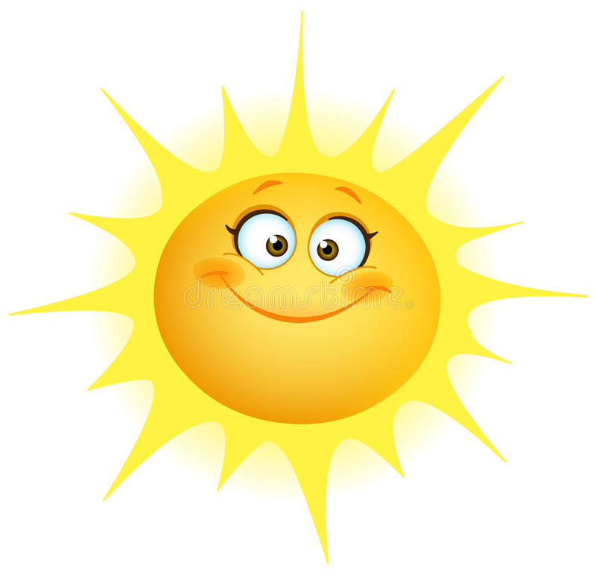

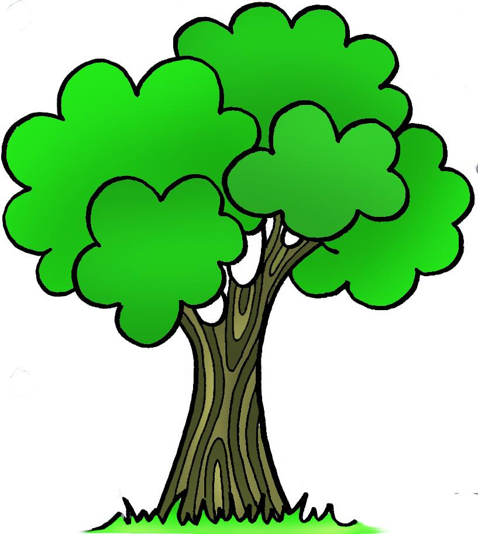

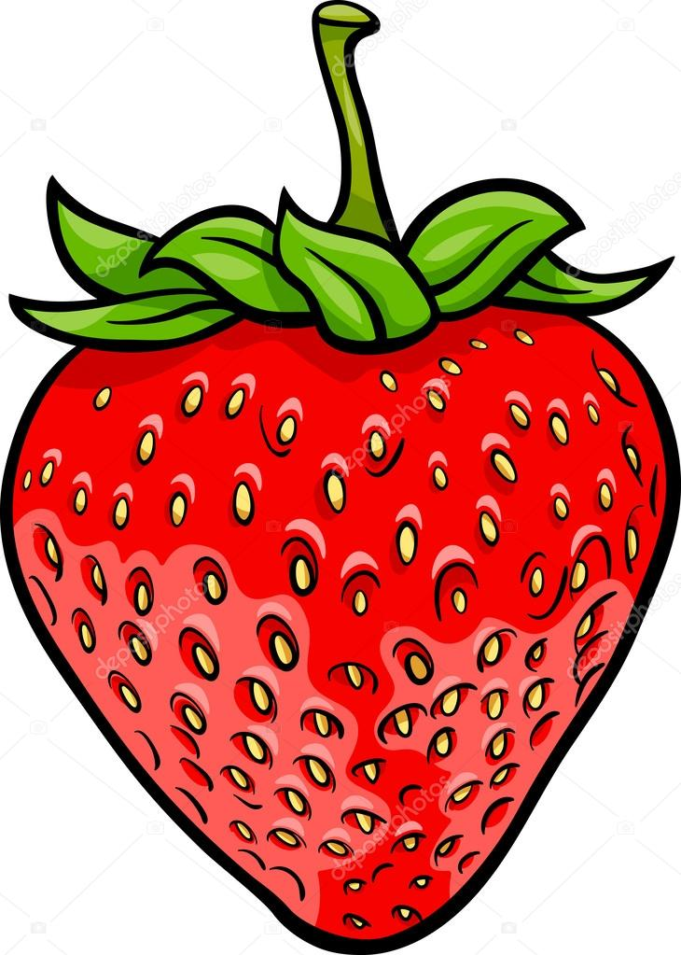
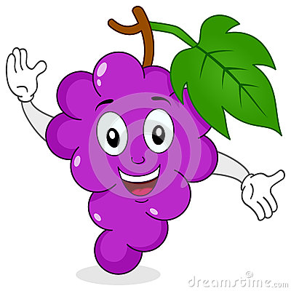
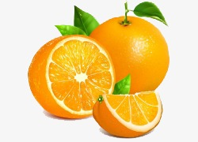
ORANGE
PURPLE
ACTIVITY 1
Name: _____________________________________________________________
Grade: ________________________________________________________

Paint each circle according to the indication and discover the color that is created.
YELLOW | + | BLUE | =
+

YELLOW | + | RED | =

+
=

YELLOW | + | RED | =

=
+

THE COLRS PRIMARY AND SECUNDARY:
We are walking on the park
under the yellow sun,
surrounded by the trees Primer grupo
that have the color Green.

Yellow is the sun,
and green are the trees, Segundo grupo
yellow is the sun,
and green are the trees.

Blue is the sky,
blue is the sea, Tercer grupo
blue is that bird,
that sing on the tree.

Strawberries are red,
purple are the grapes, Cuarto grupo
let´s make a delicious
red and purple shake.

Orange like carrots,
orange like the fruit, Quinto grupo
orange like a pumpkin
and the sun in the afternoon.

Activity N°2
Name:________________________________________________
Date__________________________________________________

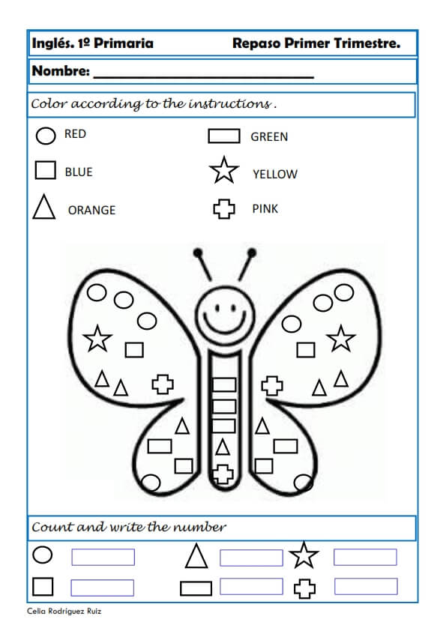
Complete the words and discover how you should paint the butterfly.
E
P
W
Y
G
R
L
E

Exam:

NAME:______________________________________________________
DATE: ____________________________________________________

To match with a line primary and secondary colors with their writing.

Green

Orange

Blue

Red

Purple

Yellow

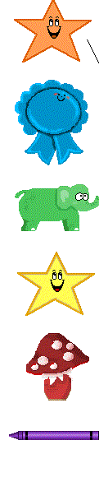

Orange

Purple
Green
Yellow
Blue
Red

